**מעבדה 5:**

מגישים:

איילון בן סימון – 312162951

סער ויקטור – 312392822

תרגיל 1 – ייצוג מספרים שלמים:

השלם בטבלה (ערכים דצימלים והקסאדצימלים) עפ"י הדוגמא:

|  |  |  |  |
| --- | --- | --- | --- |
| ערך כמספר מסומן | ערך כחסר סימן | הקסאדצימלי | מספר בינארי |
| 1- | 65535 | FFFF | 1111111111111111 |
| -32753 | 32783 | 800F | 1000000000001111 |
| 32767 | 32767 | 7FFF | 0111111111111111 |
| 21845 | 21845 | 5555 | 0101010101010101 |
| -7254 | 58282 | E3AA | 1110001110101010 |

השלם את הטבלה

**קוד תרגיל 2 (מספרים לא מסומנים):**

;lab5.asm (unsign)

.MODEL SMALL

.STACK 100h

.DATA

;define variables

N DW 11

Arr DW 1234h, 5678h, 0ff11h, 1111h, 2222h, 3333h, 4444h, 5555h, 6666h, 7777h, 8888h

Max DW 0

displayMaxunsign DB 13,10, 'Max for unsign array is: ',13,10, '$'

sixTeen DW 16

result DW 0

power DW 1

Ten DW 10

.CODE

.386

MOV AX,@DATA

MOV DS,AX

;find the maximum number in the array

MOV DI,0

MOV AX,Arr[DI]

MOV CX,N

DEC CX

maximum:

ADD DI, 2

CMP AX,Arr[DI]

JA notswap

MOV AX,Arr[DI]

MOV Max,AX

notswap:

LOOP maximum

;converts the number from hexadecimal to decimal

MOV CX, 4

convert:

MOV DX,0

DIV sixTeen

MOV BX,AX

MOV AX,DX

MOV DX,0

MUL power

ADD result,AX

;perform power of 16

MOV AX,power

MUL sixTeen

MOV power,AX

MOV AX,BX

LOOP convert

;converts the the number to bits (and insert to display array)

MOV DI,30

con:

MOV AX,result

MOV DX,0

DIV Ten

MOV result,AX

ADD DX,'0'

MOV displayMaxunsign[DI],DL

DEC DI

CMP AX, 0

JNE con

;prints the display array

MOV AH,9

MOV DX,OFFSET displayMaxunsign

INT 21H

;end the program

MOV AH,4Ch

INT 21h

END

פלט התרגיל (מספרים לא מסומנים):

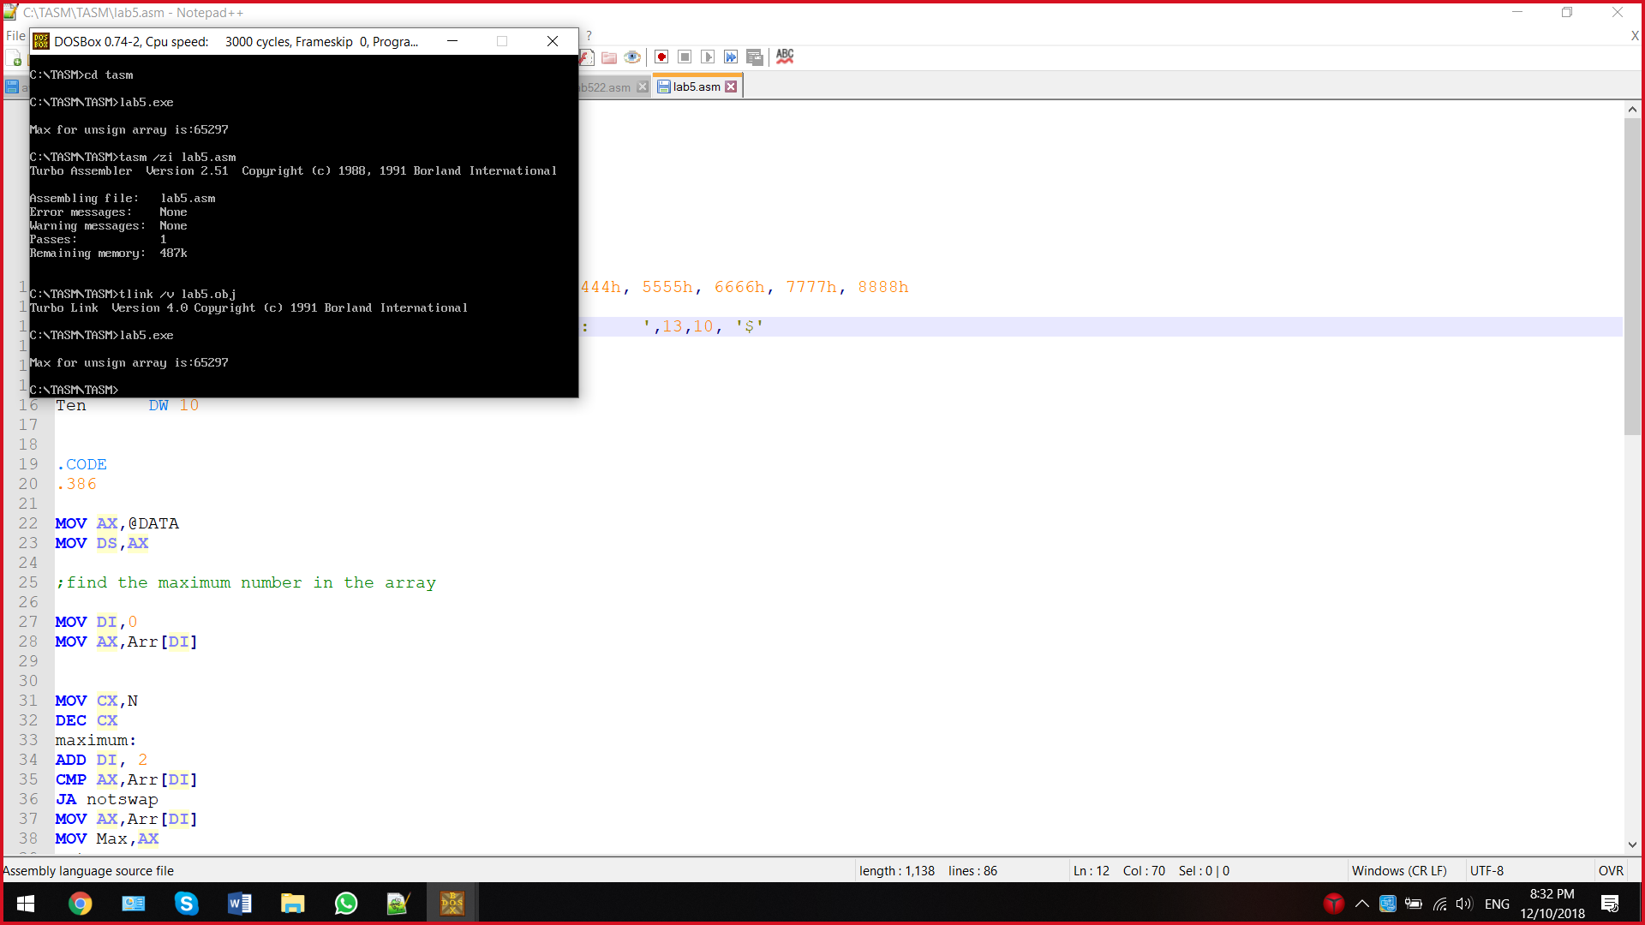

**קוד תרגיל 2 (מספרים מסומנים):**

;lab5.asm (sign)

.MODEL SMALL

.STACK 100h

.DATA

;define variables

N DW 11

Arr DW 1234h, 5678h, 0ff11h, 1111h, 2222h, 3333h, 4444h, 5555h, 6666h, 7777h, 8888h

Max DW 0

displayMaxsign DB 13,10, 'Max for sign array is: ',13,10, '$'

displayMaxsignN DB 13,10, 'Max for sign array is:- ',13,10, '$'

sixTeen DW 16

result DW 0

power Dw 1

Ten DW 10

.CODE

.386

MOV AX,@DATA

MOV DS,AX

;find the maximum number in the array

MOV DI,0

MOV AX,Arr[DI]

MOV CX,N

DEC CX

maximum:

ADD DI, 2

CMP AX,Arr[DI]

JG notswap

MOV AX,Arr[DI]

MOV Max,AX

notswap:

LOOP maximum

MOV DI,28

MOV CX, 4

;check if the number is negative or positive

CMP AX,0

JG convert

Negative:

NEG AX ;two's complement if negative

;converts the number from hexadecimal to decimal

convert:

CWD

IDIV sixTeen

MOV BX,AX

MOV AX,DX

CWD

IMUL power

ADD result,AX

MOV AX,power

;perform power of 16

CWD

IMUL sixTeen

MOV power,AX

MOV AX,BX

LOOP convert

CMP Max,0

JL displayNeg

;converts the the number to bits (and insert to display array)

;if the number is positive

displayPOS:

MOV AX,result

CWD

IDIV Ten

MOV result,AX

ADD DX,'0'

MOV displayMaxsign[DI],DL

DEC DI

CMP AX, 0

JNE displayPOS

;prints the display array

MOV AH,9

MOV DX,OFFSET displayMaxsign

INT 21H

JMP endlabel

;converts the the number to bits (and insert to display array)

;if the number is negative

displayNeg:

dispNegative:

MOV AX,result

CWD

IDIV Ten

MOV result,AX

ADD DX,'0'

MOV displayMaxsignN[DI],DL

DEC DI

CMP AX, 0

JNE dispNegative

;prints the display array

MOV AH,9

MOV DX,OFFSET displayMaxsignN

INT 21H

;end the program

endlabel:

MOV AH,4Ch

INT 21h

END

פלט התרגיל (מספרים מסומנים):

